Assignment – Food and Nutrition

Shaun Pritchard

Rasmussen College

QMB4400

Tina Harclerode

April 11, 2021

**Assignment – Food and Nutrition**

For this assignment I use Google colab to create a workbook and which I outline the project requirements for this assignment. Then imported my libraries such as pandas and numpy. I then imported data from the two CSV files **Ceral.csv** and **MFRCategorial.csv** and added them to two separate dataframes labeled *df1* and *df2*. I then use pandas ***merge*** method to a dataframe labeled *df* using an inner join on the column variable "name" I then implemented my output using the head function to validate the merge join successful.

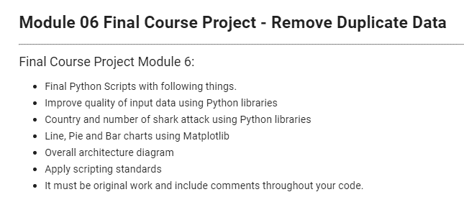

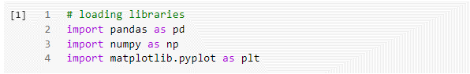

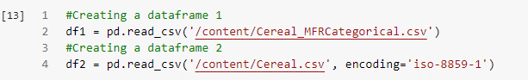

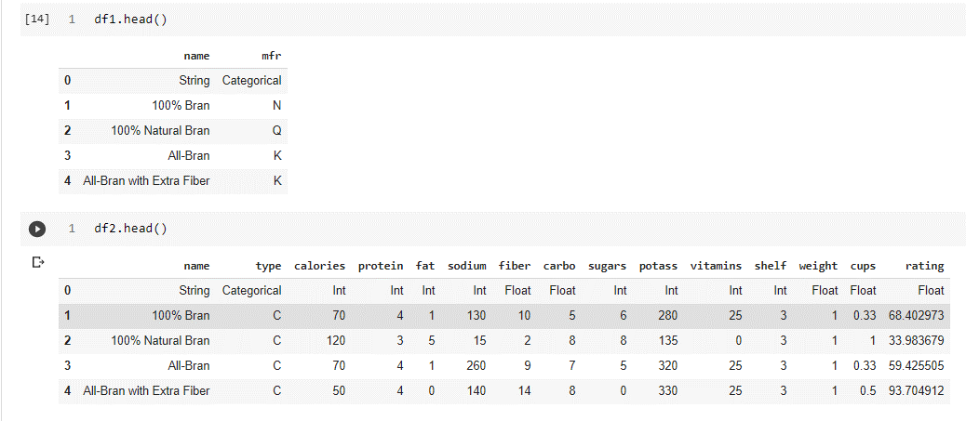

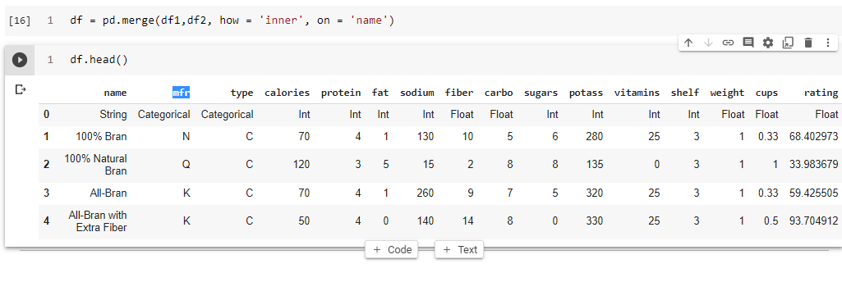

I created a jupyter notebook file as well as provided the online link to Google colab with full permissions to very my work.

<https://colab.research.google.com/drive/1cw-0ZsCps4m1VG6Clhitmil-40_Qq5Dh?usp=sharing>